TEWIN MEMORIAL HALL MANAGEMENT COMMITTEE

Minutes of Meeting held Wednesday, 23rd June 2021
7.30 pm in the Kimberley Room

Present
Keith St Pier (Chairman)
Geoff Whitbourn (Treasurer)
Todd Canton
Linda Crawford
Jim Hall
Pat Fulford

1. Apologies
DL, JL.

The committee paused to remember the sad loss of their fellow long standing committee members, Ben Roberts and Jean Canton.

2. Minutes of Previous Meeting

Minutes of the Meeting held on 26th October 2020 were accepted as a true record.

3. Group Reports

Under Fives, Brownies and Rainbows
KSP reported that the Under Fives had been running more or less normally since our last meeting. Brownies and Rainbows have probably restarted, but unclear whether they had actually used the Scout Hut yet.

Parish Council
Nothing to report.

Friends of Tewin, THACS
JH hall reported that the Classic Car show would be held in August, and that a Floral Display and Treasure Trail event had been organised for the coming weekend. Schedule has been published for THACS show in September.
Screen on the Green
Will probably restart for the next season in September.

4. Sub Committee Reports

Fabric

Since the last meeting, various work to the Scout Hut – outside had been repainted, toilet repaired, dripping taps replaced, frayed flexible pipes under basins replaced.

Leaking shower in the flat replaced. Failed zone valve in main hall replaced.

Loose covers on stage lights secured. Stage floodlight bulb replaced.

Work to do in flat – install new worktop, replace kitchen taps KSP,JH

Health and Safety
Nothing to report

Decorating
Nothing to report.

Fund Raising and Publicity

Agreed plan to have Autumn Book Sale. LC to set date. LC

No further news about fete.

The Jumble Sale committee have reduced the volume of goods in the Scout Hut, sending some to charities, some to the Book Rescuers and some to scrap. No decision yet about when to hold the next sale.

Insurance
At next renewal GW will query the value insured with the insurers.

Terms and Conditions
Nothing to report.

5. Treasurer’s Report

GW gave the Committee full details of the Hall’s finances, including expenses and working funds.

6. Supporters Club

KSP advised that the Supporters Club Draws had continued to take place during Lockdown, with the results being printed in The Tewin Magazine. TC discussing future promotion of the Club with Lisa. TC

The Draws have continued to take place during the Lockdown period – details as follows:-

June Draw May Draw

1st Prize (£55): Kenneth Feakes, West Riding 1st Prize (£55): David Marshall, Churchfield Cottages
2nd Prize (£33): Ray Keppler, Upper Green Road 2nd Prize (£33): Ian Clements, Orchard Road
3rd Prize (£11): John Langton, Firs Walk 3rd Prize (£11): Joseph Collins, Lower Green
3rd Prize (£11): Jennifer Fishwick, Godfries Close 3rd Prize (£11): Anne Beale, Upper Green

April Draw March Draw

1st Prize (£55): Andrew Groom, Bishops Road 1st Prize (£55): Lisa Bove, Wilshere Park
2nd Prize (£33): Stephen Stott, Harwood Close 2nd Prize (£33): Ivor Williams,
3rd Prize (£11): Paul Hagger, Godfries Close 3rd Prize (£11): Alf Fulford,
3rd Prize (£11): Paul Barker, Upper Green Road 3rd Prize (£11): Kevin O’Brien

February Draw January Draw

1st Prize (£55): Peter Bove, Orchard Road 1st Prize (£55): Mary Gregg, Hertford Road
2nd Prize (£33): Miles Bullivant, Fir Walk 2nd Prize (£33): Rosemary Hill, Tewin Hill
3rd Prize (£11): Paul Parker, Upper Green Road 3rd Prize (£11): Andrew Woodward, Upper Green
3rd Prize (£11): Susanne Stevens, Desborough Drive 3rd Prize (£11): Byron Sinfield, Bishops Road

December Draw November Draw

1st Prize (£55): Jacqueline Beadle, Queen Hoo Lane 1st Prize (£54): Robert Horgan, New Road
2nd Prize (£33): Roger Huggins, Hertford Road 2nd Prize (£33): Jenny Doxey, Bishops Road
3rd Prize (£11): Carol Pullen, Upper Green Road 3rd Prize (£11): Sue Angus, Upper Green Road
3rd Prize (£11): Sheila Feakes, West Riding 3rd Prize (£11): Bill Boardman, Firs Walk

During lockdown, the draws have been conducted by PF, JH, KSP drawing individual digits and sending these to Lisa. It has been suggested that if Lisa is happy with this arrangement, then it should become permanent, since it guarantees genuine draw, and saves PF finding two other people each month to do the draw under the old system.

7. Rentals

It was agreed that the current practice of allowing users of the Kimberley and Parish Rooms to use the Main Hall at no extra cost, should stop when the anticipated ending of restrictions occurs in July. Following this, all of our regular hirers should be contacted, to let them know that the hall is open and their regular slots currently remain available. PF

8. Asset Register, Time Line and Archive
Because the shop has limited storage space, we are storing their old account files in our loft.

9. Any Other Business

The hall was designed by Sir Herbert Baker. His grandson paid a visit to the hall on Friday 18th June. He was accompanied by his wife, and they were shown around by Todd. They were very impressed by the way we were keeping the hall. Thank you to Todd for making the visit a success. Afterwards, Mr Baker sent through a picture of a South African house (Blackroof, 40 The Valley Road, West Cliff, Randburg, Gauteng, Johannesburg). This was designed by Sir Herbert and built around 1910. It appears to be a precursor to the design of the Memorial Hall.

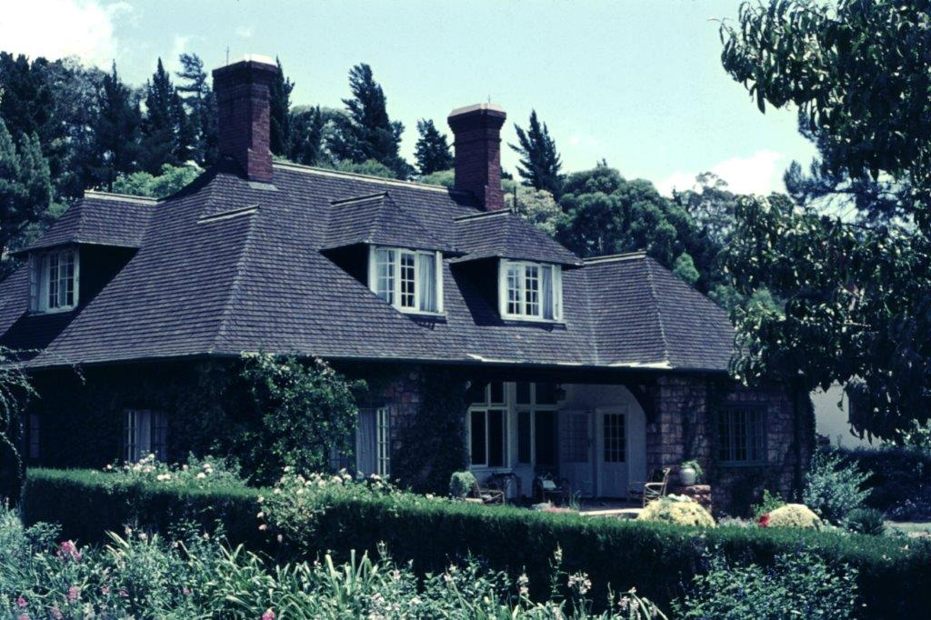

We have recently been asked to rent out tables and chairs; and to loan out our big tents.

The committee agreed to restate its policy that
(a) we don’t rent out furniture or gazebos, because we are not in that business, and we don’t want the hassle of breakages, dirty tables etc
(b) we retain the option of lending furniture and gazebos when appropriate on the basis that we know that damaged goods will be replaced
(c) because the large tents require our expertise to safely transport and erect them, we only loan them out when it is natural for us to be involved anyway e.g the Classic Car Show.

The subject of new committee members was raised. Considering the current work load, there is no immediate requirement, unless anybody knows of somebody who would be happy to be minutes secretary.

The Memorial Hall was opened on the 23rd January 1922. We are looking for ideas to mark the event without putting undue burden on the Hall Committee.

10. Date of Next Meeting:
Wednesday 21st July 2021, at 7.30 pm in the Kimberley Room.

