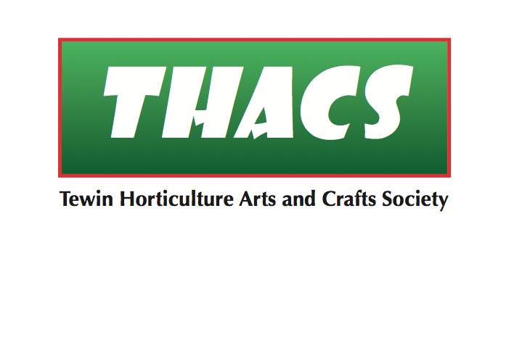

|  |  |  |  |  |  |  |  |  |  |  |
| --- | --- | --- | --- | --- | --- | --- | --- | --- | --- | --- |
|  |  |  |  |  |  |  | **RISK ASSESSMENT** |  |  |  |

|  |  |  |
| --- | --- | --- |
| Event**: Spring / Autumn Shows** | Date of event: 09/04/2022 & 24/09/2022 | Venue: **Tewin Memorial Hall** |
| Event Organiser: Ray Keppler | Other stakeholders: **Tewin Memorial Hall** |  |

| **Ref** | **Issue** | **Hazard** | **Hazard to Whom** | **Action** | **Responsible person/s** | **Comments** |
| --- | --- | --- | --- | --- | --- | --- |
| **1a.** | Physical risks | Slips, trips and falls | Organisers, committee members, helpers, guests and public | Identify and remove trailing wire and other trip hazards; if this is not possible, display a prominent hazard warning;  Mop up spills as soon as they are noticed. | RK |  |
| **1b.** | Lifting injuries; burns and scalds;  other accidents and injuries; and medical emergencies. | Advise organisers and helpers to only lift what they can carry comfortably;  Ensure organisers know the whereabouts of the First Aid box and accident book;  Ensure organisers know the whereabouts of the defibrillator and how to access it;  Record accidents in the accident book. | TMH is responsible for providing:   * first Aid box and restocking it as required; * accident book; * defibrillator. |
| **1c.** | Outbreak of fire | Ensure organisers/helpers familiarise themselves with the:   * fire emergency plan; * evacuation procedure (including helping people of limited mobility) * fire exit routes; * fire extinguishers; * fire blanket in the kitchen. * Ensure fire doors are unlocked as set out in TMH’s terms and conditions;   Ensure exit routes are kept clear;  Ensure fire extinguishers are not obscured. | TMH is responsible for providing:   * fire emergency plan; * exit signage; * fire extinguishers and fire blanket, which have been regularly maintained.   See ref [1] and [2] |
| **2.** | Covid-19 | Virus spread | Ensure compliance with government guidelines as a minimum;  Provide hand sanitiser and face masks for attendees;  Ventilate the area as much as is possible, weather permitting;  Provide additional outside seating space, weather permitting;  Reduce number of people involved in prize-giving;  Make decision to cancel events according to local infection levels. |  |
| **3.** | Food safety | Food poisoning and allergic reactions | Conduct food preparation and handling in accordance with government guidance about the provision of food at community events;  Advise customers via a prominent disclaimer that THACS cannot guarantee the accuracy of information about the ingredients of food being served. | Linda Crawford | See ref [3] |
| **4.** | Damage to Show exhibits | Loss of, or damage to, exhibits. | Show exhibitors | Issue a disclaimer stating that: - “THACS will not be responsible for any loss or damage to the exhibits.” | RK | . |

**References**

[1] Tewin Memorial Hall Terms and Conditions

[2] Tewin Memorial Hall fire procedure

[3] Food Standards Agency guidance on providing food at community and charity events

<https://www.food.gov.uk/safety-hygiene/providing-food-at-community-and-charity-events>