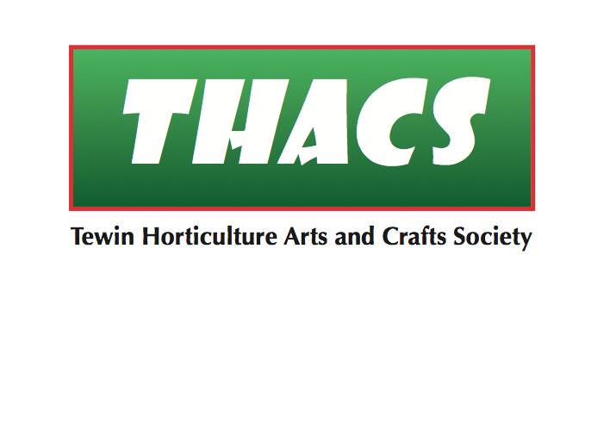

**15 Upper Green Road, Tewin, Welwyn, Hertfordshire AL6 0LE**

Jude O’Sullivan 11th March 2022

Croft House,

Wadesmill Road,

Hertford,

Hertfordshire SG14 3HJ

Dear Jude,

Thank you for agreeing to judge the art exhibits at our Spring Show on Saturday 9th April.

I enclose a copy of the show schedule and rules for your reference, and I have highlighted the categories we would like you to judge for us (categories 1, 2, 3, 4 & 5 of Class 3 Arts & Crafts (adults), category 1 of Class 6 Horticulture (children), categories 1, 2, 4, 6 & 7 of Class 7 Arts & Crafts (children)).

Please note that category 5 of Class 3 Arts & Crafts (adults) is calligraphy, so this will be a new category for you (as agreed in our emails). Also, category 1 in Class 7 Arts & Crafts is our Open Class for children, so you could have entries from any or all of the six age groups. To account for the vast ability differences amongst children of different ages, the entries will be grouped and judged in their age groups. The subject is open too, so you could have an interesting judging task! However, this is the only category to be treated this way. Please study the schedule and let me know if you’re concerned or unhappy about what I’m asking you to judge.

We are staging the show from 8.30am until 10.30am, so that all will be ready when you start judging at 10:30. However, in view of the potential high volume of exhibits for you to judge, you might wish to start earlier. If so, then please let me know and we’ll ensure that some of the categories will be ready for you from 10am. As usual, we will have a steward to help you with locating and marking the categories. We will be serving a light lunch afterwards for the judges and helpers, so I hope you can stay for that.

Thanks again for agreeing to judge and we look forward to seeing you. Meanwhile, please don’t hesitate to contact me if you have any questions.

Best wishes

Ray Keppler (Show Secretary)

Home phone: 01438-717545

Mobile phone: 07841-288244

e-mail: thacs.chair@gmail.com